

Travlr Getaways Full Stack Web Application

CS 465 Project Software Design Document
Version 1.0

Table of Contents

CS 465 Project Software Design Document 1
Table of Contents 2
Document Revision History 2
Instructions 2
Executive Summary 3
Design Constraints 3
System Architecture View 3
Component Diagram 3
Sequence Diagram 4
Class Diagram 4
API Endpoints 4
The User Interface 4

Document Revision History

Version | Date | Author | Comments
1.0 | 05/30/26 | Tanner Poulton | Initial Software Design Document created. Added Executive Summary, Design Constraints, and System Architecture View sections.

Instructions

Fill in all bracketed information on page one (the cover page), in the Document Revision History table, and below each header. Under each header, remove the bracketed prompt and write your own paragraph response covering the indicated information.

Executive Summary

The Travlr Getaways web application will be developed using the MEAN stack, which consists of MongoDB, Express, Angular, and Node.js. This architecture provides a complete JavaScript-based solution for both the client and server sides of the application. Using the same programming language throughout the application helps simplify development and maintenance while supporting future growth and additional features.
The application will include two primary interfaces. The first is a customer-facing website that allows travelers to view available trips, destinations, and travel information. This portion of the application is designed to provide users with an easy-to-use experience when browsing vacation options. The second interface is an administrator single-page application (SPA) that allows authorized users to manage trip information without reloading entire web pages. This approach improves efficiency and provides more responsive user experience for administrative tasks.
The MEAN stack architecture supports communication between the user interface, server-side application logic, and the database. Together, these components create a scalable and maintainable solution that meets the requirements of Travlr Getaways while providing a foundation for future enhancements.

Design Constraints

Several design constraints must be considered during the development of the Travlr Getaways application. The application must operate within the MEAN stack architecture, requiring compatibility between Angular, Express, Node.js, and MongoDB. Because the application is web-based, it must be accessible through standard web browsers and provide a consistent experience across different devices and platforms.
Security and data management also create important constraints. User sessions and authentication must be managed securely to protect administrative functions and travel data. The application must support communication between the client, server, and database while maintaining acceptable performance and reliability. In addition, the design should remain maintainable so future updates can be implemented without requiring major changes to the overall architecture.
These constraints influence development decisions by requiring careful planning of application structure, database integration, and user authentication. While they introduce limitations, they also provide guidelines that help ensure the final application is secure, scalable, and easier to maintain over time.

System Architecture View

Component Diagram

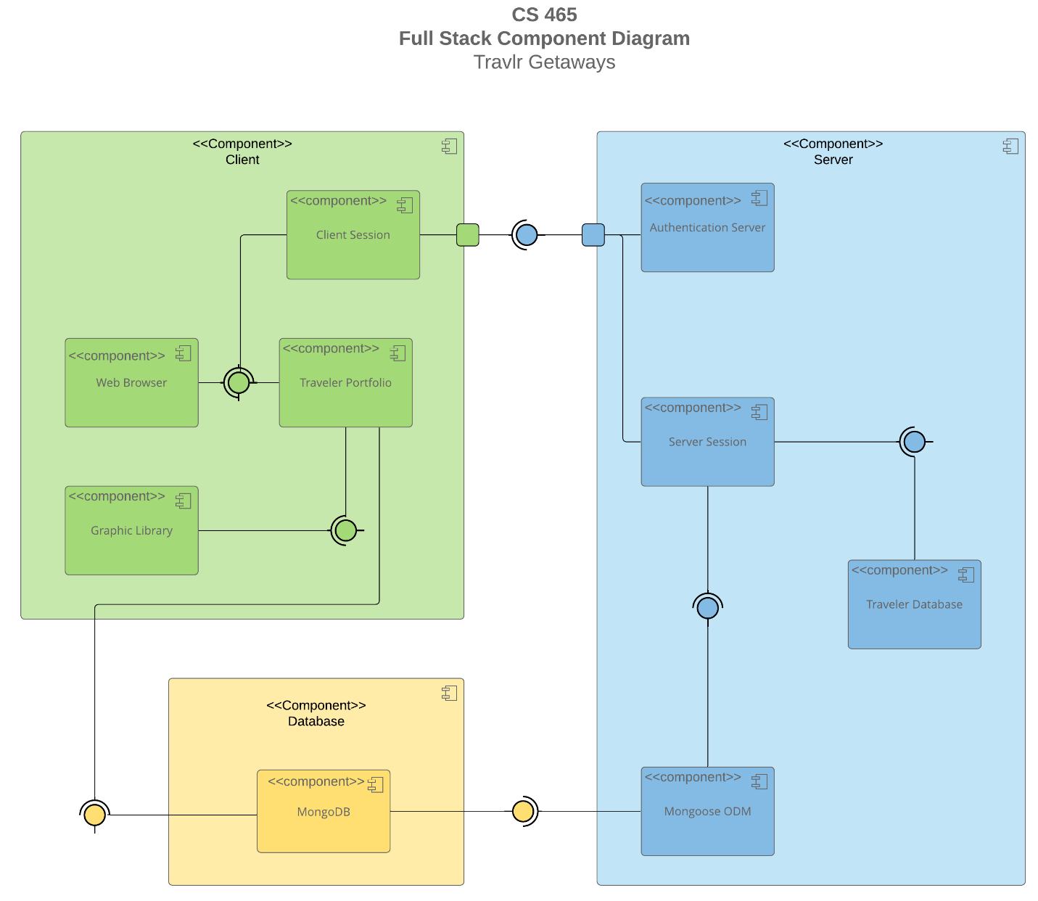

A text version of the component diagram is available: CS 465 Full Stack Component Diagram Text Version.

The Travlr Getaways application uses a three-layer architecture consisting of the client layer, server layer, and database layer. Within the client layer, users interact with the application through a web browser. The browser communicates with the Traveler Portfolio component, which provides the customer-facing interface, while the Graphic Library supports the visual presentation of content. Client sessions are maintained to manage user interactions and communication with the server.
The server layer contains the Authentication Server, Server Session, Traveler Database, and Mongoose ODM components. The Authentication Server is responsible for validating user credentials and controlling access to protected administrative functions. Server sessions manage communication between the client and server while processing requests. Mongoose ODM serves as a bridge between the application and the MongoDB database by mapping application data to database records.
The database layer consists of MongoDB, which stores trip information and other application data. Requests originate from the client, pass through the server layer for processing and authentication, and then interact with the database when information must be retrieved or updated. This layered architecture separates responsibilities among components, improves maintainability, and allows the application to scale as additional functionality is added throughout development.

Sequence Diagram

<Illustrate the flow of logic in a web application by completing a sequence diagram. Insert an image of the sequence diagram here.>

<Describe the flow of logic in the web application based on the sequence diagram. Be sure to describe the interactions between the layers, or tiers, of the full stack application. It will be helpful to include significant processes such as Sign In, Trips, and Admin interactions when referring to the sequence diagram.>

Class Diagram

<Illustrate the JavaScript classes of the web application by completing a class diagram for the web application. Insert an image of the class diagram here.>
<Describe the JavaScript classes of the web application based on the class diagram.>

API Endpoints

<Exposing RESTful endpoints is a design approach to enable an application to participate in a larger ecosystem. Document each endpoint in the table below, including the HTTP method, purpose, URL, and notes.>

Method | Purpose | URL | Notes
GET | <Retrieve list of things> | </api/things> | <Returns all active things>
GET | <Retrieve single thing> | </api/things/:thingId> | <Returns single thing instance, identified by the thing ID passed on the request URL>

The User Interface

<Insert screenshots from the development of the SPA development to show the following: (1) a unique trip, added by you, (2) the Edit screen, and (3) the Update screen.>

<Summarize the Angular project structure and how it compares to the Express project structure. Be sure to describe the rich functionality provided by the SPA compared to a simple web application interaction. Describe the process of testing to make sure the SPA is working with the API to GET and PUT data in the database.>

